3rd CORRIGENDUM

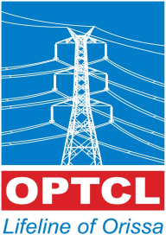
ODISHA POWER TRANSMISSION CORPORATION LIMITED.
(A Govt. Of Odisha Undertaking)
Office of the Deputy General Manager [Elect.],
EHT (O&M) Division: Chainpal, At/PO: Chainpal Colony, Dist: ANGUL.
E mail: ehtm.div.chp@optcl.co.in, CIN-U40102OR2004SGC007553

Letter no. dated:

CORRIGENDUM
With reference to this office tender notice no. 07/2021-22 for “Engagement of new Commercial Diesel Run Light Vehicle on hiring basis (AC Bolero/Equivalent) to be used at O/O the DGM, EHT (O&M) Division, Chainpal ” the sale, receipt & opening of tender papers are extended as per the following.
Date of sale of Tender Paper : up to dt. 15/02/2022.
Last Date & time of receipt of tender Paper : dt. 16/02/2022 up to 01.00PM.
Date & Time of Opening of Tender paper : dt. 16/02/2022 at 03.00PM.

All other terms & conditions mentioned in the tender notice and tender specification remain unaltered.

Sd/-
Dy. General Manager
EHT(O&M) Division, Chainpal.

